**Dual oxygen and temperature luminescence sensor based on artificial intelligence**

**FRANCESCA VENTURINI**1,2,\***, UMBERTO MICHELUCCI**2**, AND MICHAEL BAUMGARTNER**1

1*Institute of Applied Mathematics and Physics, Zurich University of Applied Sciences, Technikumstrasse 9, 8401 Winterthur, Switzerland*

2*TOELT LLC; Birchlenstr. 25, 8600 Dübendorf, Switzerland*

\**Corresponding author:* [*francesca.venturini@zhaw.ch*](mailto:francesca.venturini@zhaw.ch)

*Compiled March 17, 2020*

**The optical determination of oxygen partial pressure is of great interest in numerous areas, like medicine, biotechnology, and chemistry. A well-known approach to the optical measure of oxy- gen is based on the quenching of luminescence by molecular oxygen. Sensors based on this principle typically rely on approximate empirical models to characterize the dependence of the luminescence intensity and decay time on the oxygen concentration through a multi-parametric model (Stern–Volmer equation), whose parameters are, however, all temperature-dependent. Therefore, the temperature needs to be known to determine the oxygen concentration and is measured separately, either optically or with a completely different sensor. In this work, we propose a new artificial intelligence approach based on neural networks which allows the extrac- tion of both the oxygen concentration and the temperature using one single indicator, which is sensitive to both oxygen and temperature, and measuring only the decay time. The results show that the neural network achieves predictions of both parameters which are comparable to the accuracy of commercial senors and therefore demonstrate the feasibility of this approach. Fur- thermore, the proposed artificial intelligence approach is not limited to oxygen and temperature sensing, but can be applied to luminescence of multiple indicators, whenever the underlying mathematical model is not known or too complex to derive the desired quantities from a single measurement.**

© 2020 Optical Society of America under the terms of the [OSA Open Access Publishing Agreement](https://doi.org/10.1364/OA_License_v1)

<http://dx.doi.org/10.1364/optica.XX.XXXXXX>

## INTRODUCTION

The simultaneous determination of multiple physical quanti- ties can be very advantageous in many sensor applications, for example, when an in-situ or remote acquisition is required. If the physical effect on which the measurement method is based present cross-interference between the desired quantities, their simultaneous determination becomes a necessity. In particu- lar optical luminescence sensing is particularly attractive for multiple sensing. Using the same measuring principle, several optical elements, like optical fibers and detectors, can be shared in the setup for the detection of more than one parameter, thus allowing a compact and easy sensor design.

The typical approaches to multiple sensing are based on ei- ther the use of a single luminescence indicator (luminophore), whose luminescence is sensitive to more than one quantities or the use of several luminophores, one for each quantity, embed- ded in a substrate and placed in close physical proximity [1–6]. To be able to determine each quantity separately it is usually necessary to determine more than one optical property (e.g., ab- sorption spectrum, emission spectrum, luminescence intensity, decay time) or to use special detection schemes to take advan- tage of the differences between optical properties of the used luminophores [4, 6–10].

The problem of dual sensing is particularly relevant in appli-

cations which involve oxygen sensing. The determination of oxy- gen partial pressure is of great interest in numerous fields, like medicine, biotechnology, environmental monitoring, or chem- istry since oxygen plays an important role in many processes [4, 11]. One of the most used optical measuring approaches

molecular oxygen, which thus provides a radiationless deactiva- tion process (collisional quenching). In the case of homogeneous media characterized by an intensity decay which is a single expo- nential, the decrease in intensity and lifetime are both described by the Stern-Volmer (SV) equation [12]

uses the effect of the dynamical luminescence quenching by oxygen molecules. The measuring principle is based on the measurement of the luminescence of a specific luminophore,

*τ*

*I*0 =

*I*

*τ*0 = 1 + *KSV ·* [*O*2] (1)

whose intensity and decay time are reduced due to collisions with molecular oxygen [12].

Sensors based on this principle must rely on approximated empirical models to parametrize the dependence of the mea- sured sensing quantity (e.g., luminescence intensity or decay time) on influencing factors of the environment where the in- dicator is placed. Among these, temperature is the parameter with the strongest influence since both the luminescence and the quenching phenomena are strongly temperature dependent. Therefore, today in any optical oxygen sensor the temperature must be continuously monitored, most frequently with a sepa- rate sensor, and used to correct the calculated oxygen concentra- tion [13]. This task can be difficult in a practical implementation and may be a major source of error in sensors based on lumines-

cence sensing. Another disadvantage of this approach, is that

where *I*0 and *I*, respectively, are the luminescence intensities in the absence and presence of oxygen, *τ*0 and *τ* the decay times in the absence and presence of oxygen, *KSV* the Stern–Volmer constant and [*O*2] indicates the oxygen concentration.

For practical applications, the luminophore needs to be em-

bedded in a supporting substrate, frequently a polymer. As a result, the SV curve deviates from the linear behavior of equation (1). This deviation can be due, for example, to heterogeneities of the micro-environment of the luminescent indicator, or to the presence of static quenching [4]. A scenario which describes this non-linear behavior involves the presence in the substrate of two or more environments, in which the indicator is quenched at different rates [26, 27]. This multi-site model describes the SV curve as the sum of *n* contributions as

the parametrization of the sensor response with temperature is

*i*=1

*I* =

∑ 1 + *KSV*,*i ·* [*O*2]

(2)

system specific since it depends on how the sensing element was

*I*0 *n*

*fi* l*−*1

fabricated and on the sensor itself [14–19].

In this work we propose a revolutionary approach based on artificial intelligence. The method enables accurate dual-sensing, using one single indicator and measuring a single quantity. In- stead of describing the response of the sensor as a function of the relevant parameters through an analytical model, a neu- ral network was designed and trained to predict both oxygen concentration and temperature simultaneously. This new ap- proach is based on multi-task learning (MTL) neural network architectures.These are characterised by common hidden lay- ers, whose output is then the input of multiple branches of task specific hidden layers. MTL architectures, in facts, can learn correlated tasks [20–24] and are flexible enough to be usable in multi-dimensional regressions [25].

The collection of the large amount of data which is needed for the training and test of neural networks, cannot be performed by hand. Therefore, a fully automated setup was developed which both controls the instruments for adjusting the sensing element environment, medium gas concentration and temperature, and collects the sensor response. This allowed to collect enough

where *fi* ’s are the fractions of the total emission for each com- ponent under unquenched conditions, and *KSVi* ’s are the as- sociated effective Stern–Volmer constants. Depending on the luminophore and on the substrate material, the models proposed in the literature may be even more complex [27–29].

In most industrial and commercial sensors, the decay time *τ* is frequently preferred to intensity measurement because of its higher reliability and robustness [30]. The determination of the decay time is done most easily in the frequency domain by modulating the intensity of the excitation. As a result, the emitted luminescence is also modulated but shows a phase shift *θ* due to the finite lifetime of the excited state. This method, has the advantage of allowing very simple and low-cost realization and is widely used in commercial applications.

Although the multi-site model was introduced for lumines- cence intensities, it is frequently also used to describe the oxygen dependence of the decay times [27, 31]. Therefore, in the sim- plest case of a two-sites scenario, the model can be rewritten in terms of phase shift as [32]

measurements to train the neural network on real data and to test the sensor performance on other unseen real data.

This work proposes a paradigm shift from the classical de- scription of the response of the sensor through an approximate empirical parametric model to the use of MTL neural networks. These will learn the complex inter-parameter dependencies and sensor-specific response characteristics from a large amount of

tan *θ*(*ω*, *T*, [*O*2]) =

tan *θ*0(*ω*, *T*)

*f* (*ω*, *T*) +

1 + *KSV*1(*ω*, *T*) *·* [*O*2]

(

1

1 *− f* (*ω*, *T*) *−*1 (3)

1 + *KSV*2(*ω*, *T*) *·* [*O*2]

*−*

data automatically taken. This new method will enable to build sensors even if they are too complex to be comfortably described by a mathematical model.

## METHODS

* 1. **Luminescence Quenching for Oxygen Determination**

Luminescence-based oxygen sensors usually consist of a dye molecule (luminophore) whose luminescence intensity and de- cay time decrease for increasing O2 concentrations. This re- duction is due to collisions of the excited luminophore with

where *θ*0 and *θ*, respectively, are the phase shifts in the absence and presence of oxygen, *f* and 1 *f* are the fractions of the total emission for each component under unquenched conditions, *KSV*1 and *KSV*2 are the associated Stern–Volmer constants for each component, and [*O*2] indicates the oxygen concentration. It is to be noted that the quantities *θ*0, *f* , *KSV*1, and *KSV*2 are all non-linearly temperature dependent [33–35] and may result frequency dependent, an artifact of the approximation of the model. Finally, Eq. 3 needs to be inverted to determine [*O*2] from the measured quantity *θ*. The proposed approach defies the need of the mathematical model through the use of neural

# 

N2

air

by a lens and collected by a photodiode (SFH 213 Osram). To suppress stray light and light reflected by the sample surface, the emission channel was equipped with a long pass filter with cut- off at 594 nm (Semrock 594 LP Edge Basic long pass) and a short pass filter with cut-off at 682 nm (Semrock 682 SP Bright Line HC short pass). The driver for the LED and the trans-impedance amplifier (TIA) are self-made. For the frequency generation and the phase detection a two-phase lock-in amplifier (SR830, Stanford Research Inc.) was used.

***B.2. Automated Data Acquisition***



LED

405nm

PD

SP

Lens

SP

LP

Lens

Sample

Dry

Temperature controller

Gas mixer

Computer

LED Driver

TIA

Lock-in

The large amount of data needed for the training and the test of the neural network was acquired using an automated acquisition program which followed the flow-chart shown in Fig. 2. First, the program fixed the temperature and concentration. Then, the phase-shift was measured for 50 modulation frequencies between 200 Hz and 15 kHz. This measurement was repeated 20 times. Next, keeping the temperature fixed, the program changed the oxygen concentration and the entire frequency-loop was repeated. The oxygen concentration was varied between

**Fig. 1.** Schematic diagram of the experimental setup. Blue indicates the excitation optical path, red the luminescence one. SP: short pass filter; LP: long pass filter PD: photodiode; TIA: trans-impedance amplifier.

network approach. However the structure of Eq. 3 remains relevant to understand the structure of the data and optimize the architecture of the neural network.

* 1. **Experimental Procedure**

The optical setup used in this work for the luminescence mea- surements is shown schematically in Fig. 1. To be able to acquire a large number of data, both the software for the instrument con- trol and for the data acquisition was written using the software LabVIEW by National Instruments. The acquisition procedure is described in detail in Sect. B.2.

* + 1. ***Experimental Setup***

The sample used for the characterization and test is a commer- cially available Pt-TFPP-based oxygen sensor spot (PSt3, PreSens Precision Sensing). To control the temperature of the samples, these were placed in good thermal contact with a copper plate, placed in a thermally insulated chamber. The temperature of this plate was adjusted using a Peltier element and stabilized with a temperature controller (PTC10, Stanford Research Systems). The thermally insulated chamber was connected to a self-made gas-mixing apparatus which enabled to vary the oxygen concen- tration between 0 % and 20 % vol *O*2 by mixing nitrogen and dry air from two bottles. In the following, the concentration of oxygen will be given in % of the oxygen concentration of dry air and indicated with % air. This means, for example, that 20

% air was obtained by mixing 20 % dry air with 80 % nitrogen and therefore corresponds to 4 % vol *O*2. The absolute error on the oxygen concentration adjusted with the gas mixing device is estimated to be below 1 % air.

The excitation light was provided by a 405 nm LED (VAOL- 5EUV0T4, VCC Visual Communications Company LLC), filtered by a short pass (SP) filter with cut-off at 498 nm (Semrock 498 SP Bright Line HC short pass) and focused on the surface of the samples with a collimation lens. The luminescence was focused

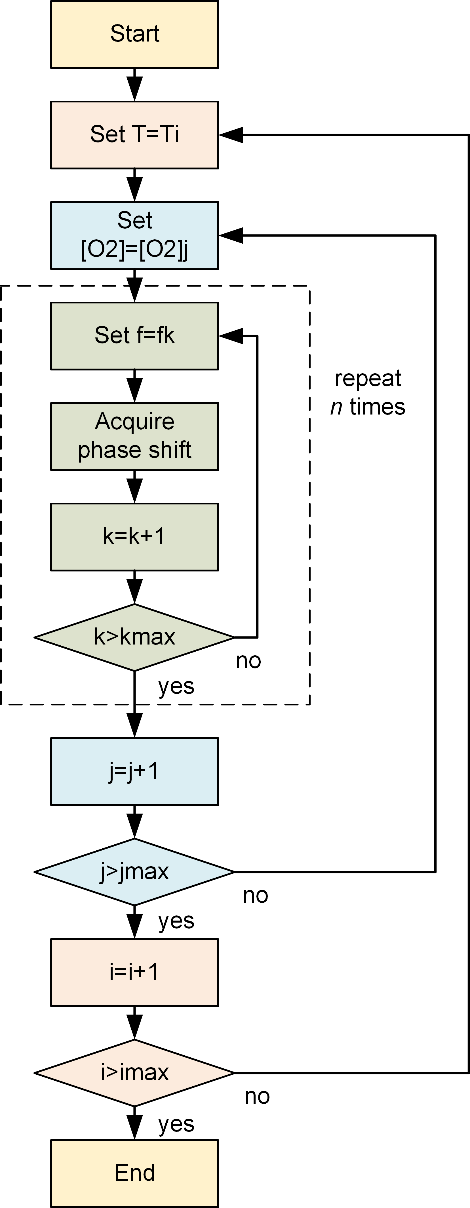

**Fig. 2.** Flow-chart of the automated data acquisition program.

0 % air and 100 % air in 5 % air steps. Finally, the temperature was changed and then the oxygen and frequency loops where repeated. The temperature was varied between 5 *◦*C and 45

* C in 5 *◦*C steps. The total number of measurements was thus 50 x 20 x 21 x 9 = 189’000 which required a total acquisition time of approximately 65 hours. This number of measurement was chosen as a compromise between maximizing the number of data for the training of the neural network and avoiding photodegradation, which naturally occurs when the sample is subjected to illumination. A the end of the session a minimal change in the phase shift was observed.
  1. **Neural Network Approach**

The software component of this new sensor type is based on a neural network model (NNM). A NNM is made of three com- ponents [36]: a neural network architecture (that includes how neurons are connected, the activation functions and all the hy- perparameters), a loss function (here indicated with *L*) and an optimiser algorithm. In this section those three components are described in detail.

* + 1. ***Neural Network Architecture***

The artificial network used in this work has a multi-task-learning architecture and is depicted schematically in Figure 3. It consists of three *common hidden layers* common hidden layers with 50 neurons each which generate as output a "shared representa- tion". The name comes from the fact that the output of those layers is used to predict both [*O*2] and *T*. These are followed by three branches, one without additional layers to predict [*O*2] and *T* at the same, and two with each two additional *task-specific hidden layers* to predict respectively [*O*2] and *T*. The shared rep- resentation is the input of two "task-specific hidden layers", that learn how to predict [*O*2] and *T* better. This architecture uses the common hidden layers to find common features beneficial to each of the two tasks. During the training phase, learning to pre- dict [*O*2] will influence the common hidden layers and therefore, the prediction of *T*, and vice-versa. The further task-specific hidden layers learn features specific to each output and there- fore improve the prediction accuracy. The number of neurons of each task-specific hidden layer used in this work is five. The activation function is the sigmoid function for all the neurons. A study of which network architecture works best with this kind of data can be found in [25].

The network, as will be explained in in the results section, has been trained with two types of input. In the first case each observation consists of a vector of 50 values defined as

(

1

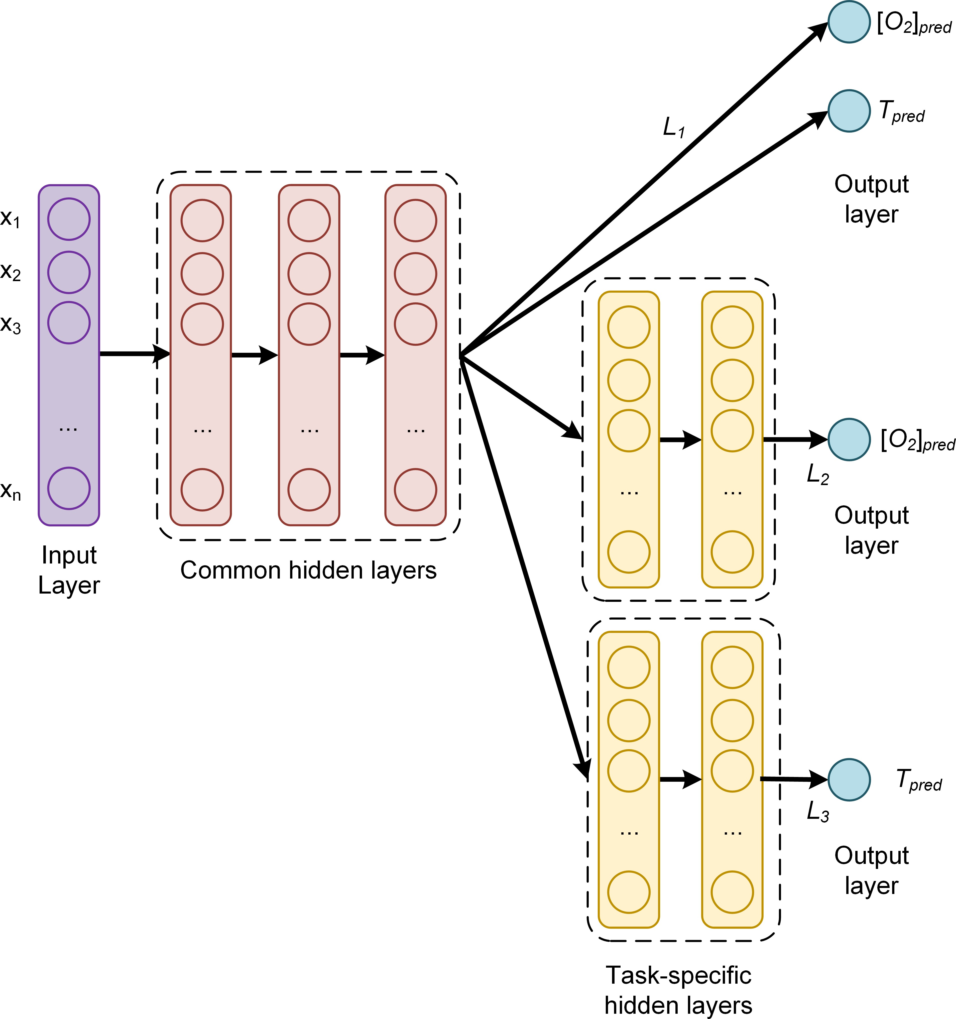

**Fig. 3.** Architecture of the multi-task learning neural network used in this paper. The common hidden layers generate as out- put a "shared representation" that is used as input to task spe- cific branches that learn specific features to each quantity and therefore improve the prediction accuracy. *x*1...*xn* are the input observations; *Li* are the task-specific loss functions; [*O*2]*pred* and *Tpred* are the oxygen concentration and temperature pre- dictions of the network respectively.

where *n* is the number of observations in the input dataset; ***y***[*j*] R*di* is the measured value of the desired quantity for the *jth* observation (indicated as a superscript between square brackets), with *j* = 1, ..., *n* for the *ith* branch and *di* is the dimension of the neural network branch output. In this case *d*1 = 2, *d*2 = 1

*∈*

and *d*3 = 1. ***y***ˆ[*j*] R*di* is the output of the network branch *i*, when evaluated on the *jth* observation. Since there are multiple

*∈*

branches, a global loss function *L* needs to be defined as a linear combination of the task-specific loss functions with weights *αi*

*nT*

*L* = ∑ *αi Li* . (7)

***θ****s* =

*θ*(*w*1) ,

90

*θ*(*w*2) , ..., 90

*θ*(*w*50)

90

(4)

The parameters *αi*

*i*=1

have to be determined during the hyper-

where *wi* are the 50 values of the modulation frequencies used in the experimental setup. In the second case the input used is

***θ****n* = ( *θ*(*w*1) , *θ*(*w*2) , ..., *θ*(*w*50) 1 (5)

parameter tuning phase to optimize the network predictions. In this paper, being the loss function the MSE (Eq. 6), the global loss function results

*nT* 1 *n di*

*θ*0(*w*1) *θ*0(*w*2) *θ*0(*w*50)

*L* = ∑ *αi* ∑ ∑(*y*[*j*] *− y*ˆ[*j*] )2 (8)

where *θ*0(*wi* ) is the value of the phase shift without oxygen

*i*=1 *n j*=1 *k*=1 *k k*

quenching at the modulation frequency *wi* .

* + 1. ***Loss Function***

The task specific loss functions *Li* are the mean square error (MSE), which is defined as

1 *n di*

where *nT* is the number of tasks. The global loss function weights used for the plots were *α*1 = 0.3, *α*2 = 5 and *α*3 = 1 [25].

* + 1. ***Optimiser Algorithm***

To minimize the loss function, the optimizer Adaptive Moment Estimation (Adam) [36, 37] was used. The training was per-

*Li* = ∑ ∑(*y*[*j*] *− y*ˆ[*j*] )2, *i* = 1, 2, 3 (6)

formed with a starting learning rate of 10*−*3. Two types of

*n j*=1 *k*=1 *k k*

training were investigated to compare the training efficiency

and performance of the network. *No-batch training*: with this method all the training data are used to perform an update of the weights and to evaluate the loss function. The loss function used is given by Eq. (6) where *n* is the total number of obser- vations available (3780). *Mini-batch training*: with this method the weight update is performed after the network has seen 32 observations. In this case Eq. (6) is used with *n* = 32. For each weight update, 32 random observations are chosen from the training dataset without repetitions until all the training data has been fed to the network.

No-batch training has the advantage of stability and speed, since it performs one weight update using the entire training dataset. Mini-batch training is normally much more effective, allowing to reach smaller values of the loss function in less epochs, but normally takes more time [36]. In our experiments for 20 103 epochs No-batch training took roughly five minutes on a modern MacBook Pro, while mini-batch training with *b* = 32 took roughly 1 hour, thus resulting ca. 12 times slower. The

*·*

***D.3. Error Limited Accuracy*** *η*

Generally, in a commercial sensor the accuracy quantifies the performance of the sensor and helps deciding if it chosen device is appropriate for the application of interest. The above defined *AE* and *MAE* are useful to compare the performance of different NNM but are not helpful in quantifying which error the neural network senor will ultimately have im practice. For this reason in this work we introduce a new metric, which we will call Error Limited Accuracy (ELA) and that we indicate with *η*.

**Definition.** *In a regression problem, given a metric m, and a certain value of it m*ˆ *, the ELA for this metric η limited by the error m*ˆ *is defined as the number of predictions y*ˆ *of the NNM that lie in the range* [*m*(*y*ˆ) *m*ˆ , *m*(*y*ˆ) + *m*ˆ ] *divided by the total number of observations. It will be indicated with η*(*m*ˆ )*. Therefore, given a set*

*−*

*E*(*m*ˆ ) = *{y*ˆ[*i*] *with i* = 1, ..., *n ||m*(*y*ˆ[*i*] ) *− m*(*y*[*i*])*| ≤ m*ˆ *}* (11)

*η is defined as*

implementation was performed using the TensorFlow™ library.

* 1. **Performance Evaluation**

*η*(*m*ˆ ) = *|E*(*m*ˆ )*|*

*n*

(12)

To evaluate the performance of the sensor different quantities were analyzed and are discussed in the next sections.

* + 1. ***Absolute Error on the Prediction***

The metric used to compare predictions from expected values is the absolute error (*AE*) defined as the absolute value of the difference between the predicted and the expected value for a given observation. Note that in the architecture described in the previous sections, only branch 1 and 2 can predict [*O*2], while *T* can be predicted by branch 1 and 3. In all the results shown in the following sections the predicted [*O*2] is from branch 2, while the predicted *T* is from branch 3. For the oxygen concentration for the *jth* observation [*O*2][*j*] the *AE* is

*where E*(*m*ˆ ) *is the cardinality of the set E*(*m*ˆ ) *or in other words, the number of its elements.*

This metric allow to interpret the regression problem as a classification one. *η*(*m*ˆ ) simply describes how many observa- tions are predicted by the NNM within a given value of the chosen metric *m*ˆ . If we now choose the metric *m* as the *AE* of the predictions, *η*(*AE*) has a very intuitive and useful interpretation. In this case *η*(*m*ˆ ) with *m*ˆ = *A*ˆ*E*, is simply the percentage of predictions that are within a certain error *m*ˆ from the expected values. Finally, if we take *m*ˆ big enough, all the predictions will be classified perfectly, so *η* is expected to approach 1 for large *m*ˆ values. The smaller *m*ˆ the smaller the number of predictions correctly classified will be.

*| |*

[*j*]

*AE*

[*O*2]

= *|*[*O*2][*j*]

[*j*]

[ 2]*meas*

*− O*

*|*. (9)

A special case is the value *m* = *m* for which *η*(*m*) = 1. Be- cause within *m* the network would predict all the observations

Where [*O*2][*j*] and [*O*2][*j*] are respectively the [*O*2] network prediction and expected value. The further quantity used to analyse the performance of the network is the mean absolute error (*MAE*), defined as the average of the absolute value of the difference between the predicted and the expected oxygen concentration or temperature. For example, for the oxygen pre-

*pred*

*pred*

*meas*

diction using the training dataset *Strain*, the *MAE*[*O*2 ] is defined as

correctly. This value (*m*) will give us the biggest error in the sensor predictions.

## RESULTS AND DISCUSSION

* 1. **Luminescence Experimental Results**

As described in Section A, the phase-shift non-linearly depends on the oxygen concentration as described by the Stern-Volmer

*MAE*[*O*2 ]

1

(*Strain* ) =

*S*

*| train| j*

∑

*∈Strain*

[*j*]

[ 2]*pred*

*| O*

[*j*]

[ 2]*real*

*− O*

*|* (10)

where *Strain* is the size (or cardinality) of the training dataset.

*| |*

*AET* and *MAET* are similarly defined, using *T* instead of [*O*2].

* + 1. ***Kernel Density Estimation***

To analyze the performance of the network, a fundamental quan- tity is the prediction probability density distribution of the *AE*s since it carries information on the probability of the network to predict the expected value for each parameter. For this reason and to make a clear visualisation of the results the kernel den- sity estimate (KDE) of the distributions of the *AE*s for both the oxygen concentration and the temperature was calculated. KDE is a non-parametric algorithm to estimate the probability den- sity function of a random variable by inferring the population distribution based on a finite data sample [38]. In this work a Gaussian Kernel and a Scott bandwidth adaptive estimation [39] using the seaborn Python package [40] were used.

**Fig. 4.** Measured phase shift as a function of the oxygen con- centration for selected temperatures at a fixed modulation frequency of 6 kHz. The arrow marks increasing temperatures.

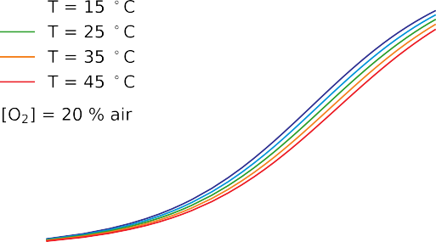

**Fig. 5.** Measured phase shift as a function of the modulation frequency for selected temperatures at a fixed oxygen concen- tration of [*O*2] = 20%. The arrow marks increasing tempera- tures.

equation. Additionally, the phase shift depends on the tem- perature, which influences the luminescence and the collision mechanisms, and on the modulation frequency of the excitation light as described in Eq. 3. The measured behaviour of the phase shift for variations of these three quantities are shown in the Figs. 4 to 6.

Fig. 4 shows the measured phase shifts as a function of the oxygen concentration at a constant modulation frequency of 6 kHz for increasing temperatures. For clarity, only curves at five temperatures are shown. The decrease of the phase shift due to the collisional quenching is evident for all curves. The phase shift is, as expected, also strongly depends on the temperature. In absence of oxygen the phase is reduced with increasing *T* due to temperature quenching; by higher oxygen concentrations the influence of temperature depends on the concentration, being stronger at higher oxygen concentration, as a result of the change of diffusion rates of oxygen in the sample substrate.

For a given oxygen concentration the phase shift is strongly dependent from the modulation frequency, as it can be seen in Fig. 5, and the shape of the frequency response is determined by the distribution of decay times of the sample. The effect of the temperature of the frequency response is visible in the reduction of the phase shift with increasing temperatures. This affects the phase shift differently depending on the modulation frequency. For comparison, the effect of the oxygen concentration on the frequency response at a fixed temperature is shown in Fig.

6. Compared to Fig. 5, the frequency response of the sample is much stronger affected by the oxygen concentration than by temperature. In other words, the sample has a higher sensitivity to oxygen than to temperature.

Comparing the curves shown above it is clear that, when measuring one single phase shift or even a the phase shift as a function of the modulation frequency, namely the frequency response, is not possible to simultaneously determine both the oxygen concentration and the temperature from this set of data and from Eq. (3). The temperature must be known separately and used to determine the oxygen concentration. This is no longer the case with the artificial intelligence approach, as it will be shown in the next section.

* 1. **Sensor performance**

Let’s start with discussing what is the effect of using mini- batches versus not using them. The results can be seen for

*AE*[*O*2 ] and *AET* in Figure 7(A) and 7(B) respectively. For this comparison the network was trained for 20000 epochs using the input observations as defined in Eq. (4). In the Figure the gray histogram shows the results when using mini-batches of size 32, while the blue when using no-batch. The effect is extraordi- nary. The predictions move from (without using batches) having

MAE[*O*2 ] = 2.38 % air and MAE*T* = 3.63*◦* C to MAE[*O*2 ] = 1.36

% air and MAE*T* = 1.63*◦* C (while using mini-batches of size

32). Not only the average values are reduced but the predictions distributions are much narrower. From Figure 7(A) and 7(B) it can also be clearly seen that, even while using mini-batches, we can get errors as high as roughly 5 % air for [*O*2] or roughly as

12 *◦* C for *T*. While deciding what is the right mini-batch size,

training time must be taken into account. In fact decreasing the mini-batch size have the side effect of increasing the training time. While training the network without batches requires just a few minutes, reducing the mini-batch size to 32 increase the training time to roughly 1 hour.

One can get much better results simply training the network for many more epochs. In Figure 7(C) and 7(D) the difference between predictions distributions with 20000 and 100000 epochs (always using a mini-batch of size 32) is shown, again when using the input observations as defined in Eq. (4). The results are dramatically better. When the network has been trained for 100000 epochs we have a MAE[*O*2 ] = 0.22 % air and a MAE*T* =

0.27*◦* C. Additionally all the predictions for [*O*2] lies below 0.94

% air, and for *T* lie below 2.1 *◦* C. To train a network for so many epochs requires, on a modern laptop, roughly 5 hours. Predicting both [*O*2] and *T* at the same time from the same set of data with such accuracies is unprecedented and paves the way to a completely new generation of sensors that does not need to measure temperature independently to predict the oxygen concentration.

In Figure 7(E) and 7(F) predictions distributions are shown when using input observations as defined in Eq. (5), with a mini-batch size of 32 and 20000 epochs. The results are clearly better, especially for the temperature predictions. Training the network with these inputs require roughly 1 hour. Additionally all the predictions for [*O*2] lies below 0.87 % air, and for *T* lies below 1.7 *◦* C.

The performance of the different neural networks is summa- rized in Table 1.

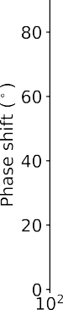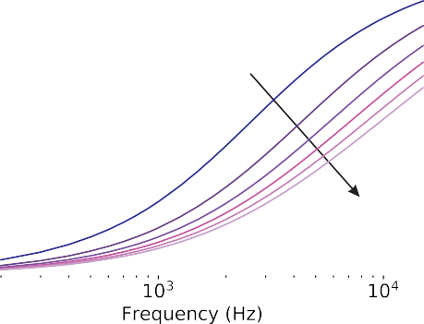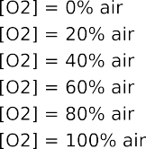

**Fig. 6.** Measured phase shift as a function of the modulation frequency for selected oxygen concentrations at a fixed tem- perature of *T* = 25*◦*. The arrow marks increasing oxygen concentrations.

# 

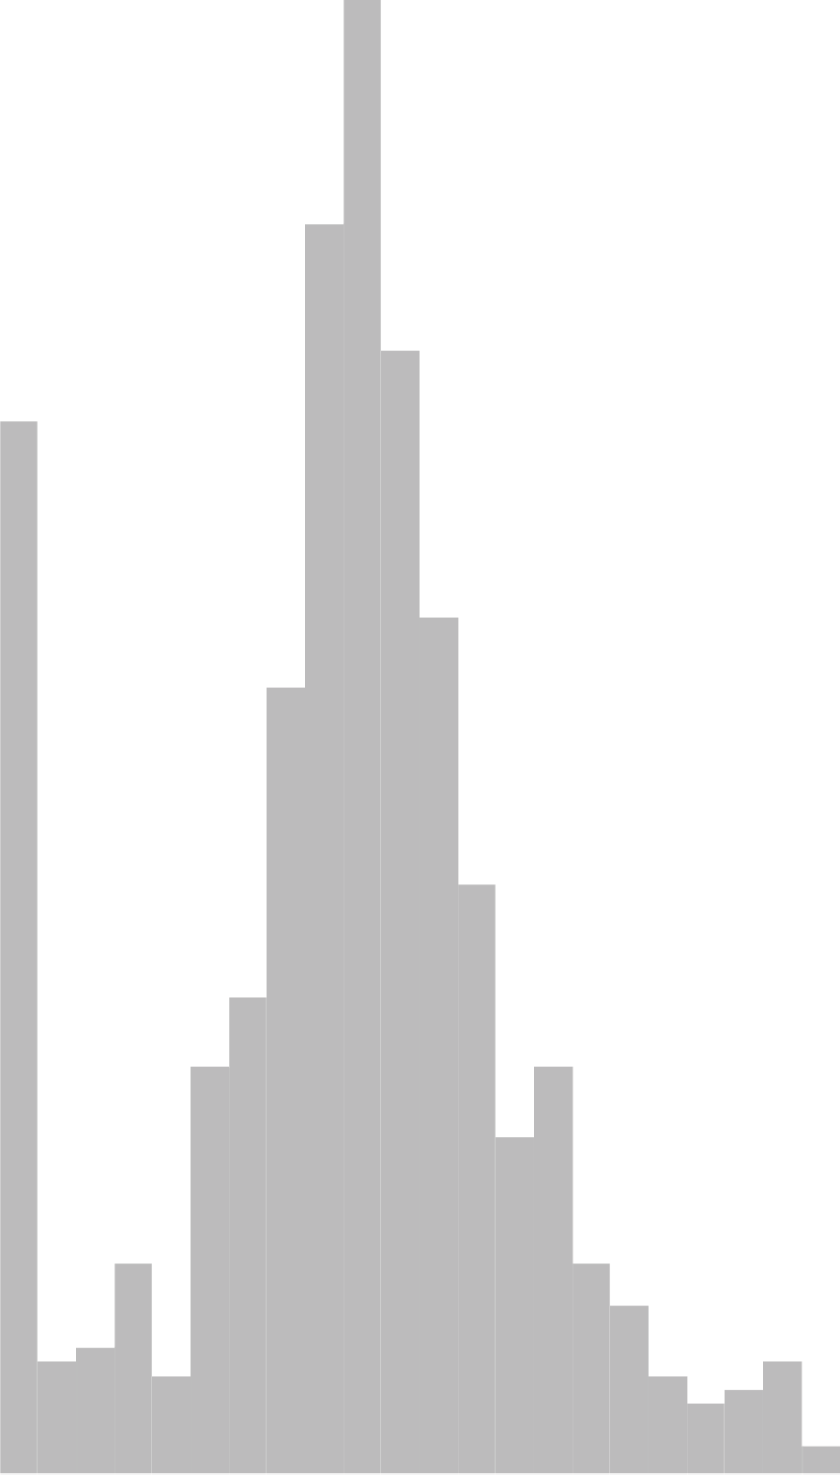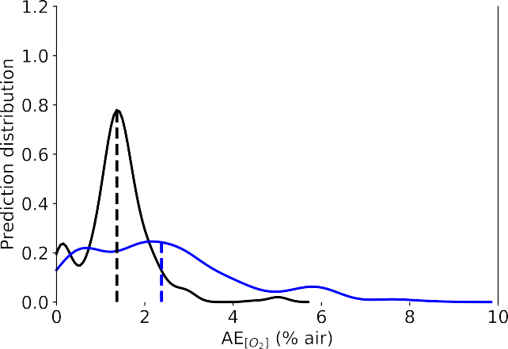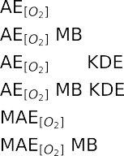

(A)

N

N

N

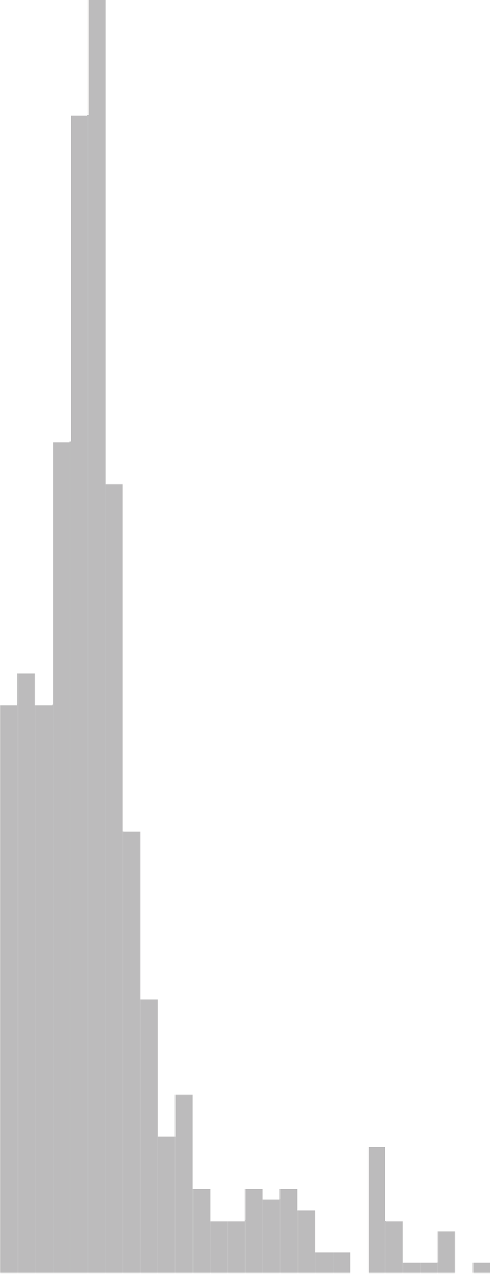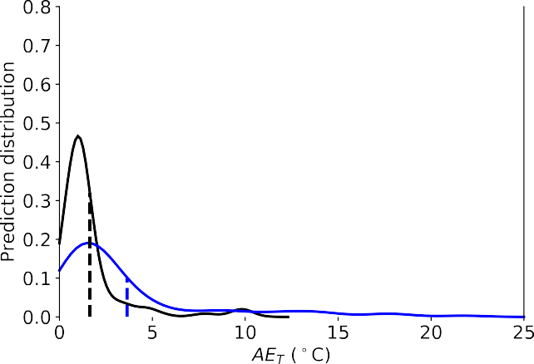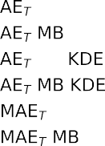

(B)

N

N

N

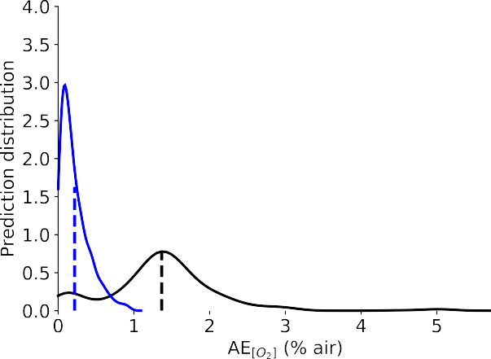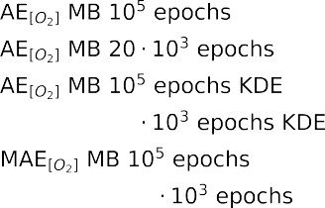

(C)

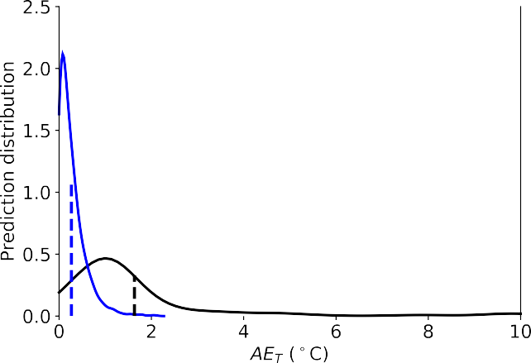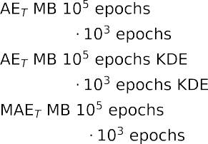

(D)

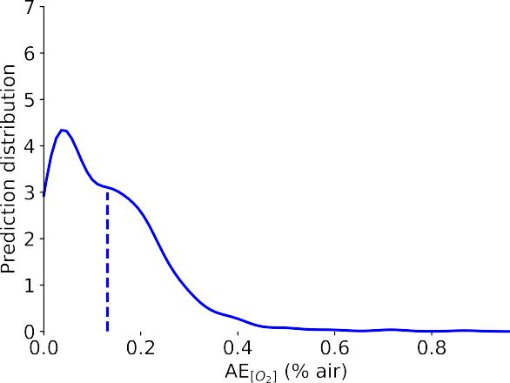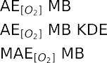

(E)

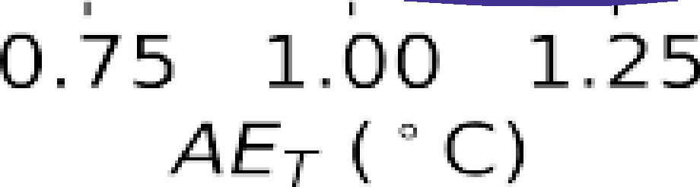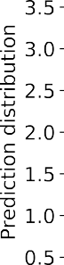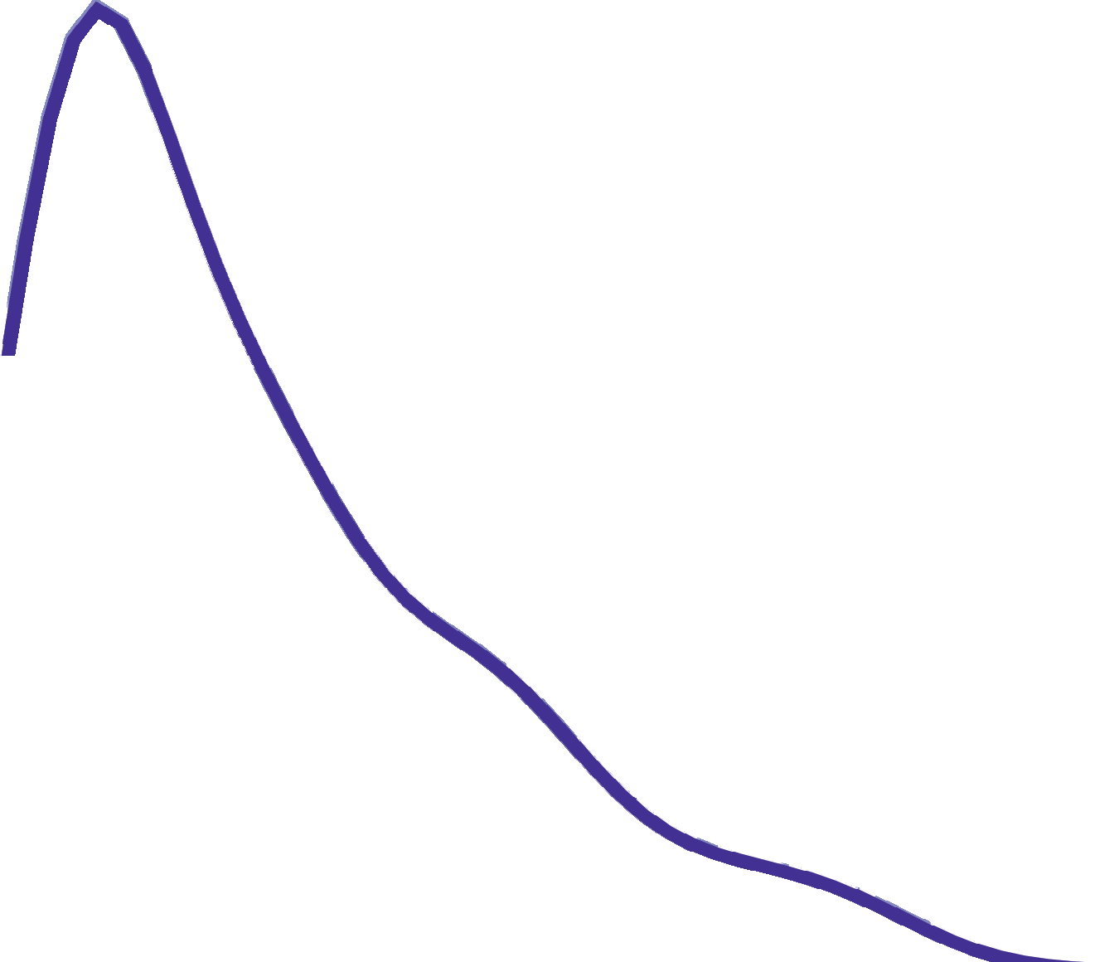

(F)

**Fig. 7.** Performance of the neural network for the oxygen (panels (A), (C) and (E)) and for the temperature (panels (B), (D) and (F)) predictions. In all panels the normalized prediction distribution histogram (columns), the kernel density estimate (KDE) of the distribution of the *AE*s (solid line), and *MAE* (dashed vertical line) are shown. Panels (A) and (B): Comparison between training using no batches (NB) and using mini-batches (MB) with a batch size of 32; the input of the network are observations as defined in Eq. (4). Panels (C) and (D): Comparison between training using mini-batches (MB) with a batch size of 32, training the network for 100’000 ans 20’000 epochs; the input of the network are observations as defined in Eq. (4). Panels (E) and (F): training using mini-batches (MB) with a batch size of 32, for 20’000 epochs; the input of the network are observations as defined in Eq. (5).

### Table 1. Summary of the performance for the three types of neural network models

|  |  |  |  |
| --- | --- | --- | --- |
| Input Epochs / Batch size | | *MAE*[*O*2 ] | *MAE*[*T*] |
| ***θ****s* 20’000 / no batch | | 2.38 % air | 3.63 *◦C* |
| ***θ****s* | 20’000 / 32 | 1.36% air | 1.63 *◦C* |
| ***θ****s* | 100’000 / 32 | 0.22 % air | 0.27 *◦C* |
| ***θ****n* | 20’000 / 32 | 0.13 % air | 0.24 *◦C* |

**Table 2. Summary of the values of** *m*1 **for the cases shown in Figure** **8****(A) and** **8****(B).**

|  |  |  |  |
| --- | --- | --- | --- |
| Input | Epochs / Batch size | *AE*[*O*2] | *AET* |
| ***θ****s* | 100’000 / 32 | 0.95 % air | 2.05 *◦C* |
| ***θ****n* | 20’000 / 32 | 0.87% air | 1.67 *◦C* |

* 1. **Error Limited Accuracy Plots**

The discussion in the previous sections helps in measuring how the network behave and how good the predictions are, but makes understanding what sensor we could build with such model almost impossible. For a sensors one has to be able to esti- mate the maximum error for the measurements. To achieve this we developed a completely new metric: the ELA (*η*), as defined in section D.3, that will allow us to characterise the sensor with a maximum error. As explained previously, *η* is defined only when one chooses a metric *m*. In this section the metric chosen is *m* = *AE*[*O*2 ] for the oxygen concentration and *m* = *AET* for the temperature.

In Figure 8(A) and 8(B) you can see a comparison of *η*(*AE*[*O*2 ]) and *η*(*AET* ) for network trained with mini-batches of size 32 and for 20000 and 100000 epochs. The black line are the results for the network that have been trained with ***θ****n* as input for 20000 epochs, while the red one with ***θ****s* as input for 100000 epochs for the oxygen concentration.

The dashed lines indicates the values of the *AE*[*O*2 ] for which the predictions would give a 100 accuracy within that error. For example for the network trained with ***θ****s* as input, the model would predict perfectly all the oxygen concentrations within

0.95 % air error. For the network trained with ***θ****n* this value would be 0.87 % air.

In Figure 8(B) the same analysis can be found for *m* = *η*(*AET* ). The interpretation is similar to the one given above for the oxygen concentration predictions. For the network trained with ***θ****s* as input, the model would predict perfectly all the T values within *AET* = 2.05*◦*C error. For the network trained with ***θ****n* this value would be *AET* = 1.67*◦*C. Those results are summarised in Table 2.

**4. CONCLUSIONS**

The results in the prediction of the oxygen concentration and temperature show unprecedented accuracy for both parameters, demonstrating that this approach will make a new generation of sensors possible for dual or even multiple sensing. The unprece- dented accuracy in predicting both *AE*[*O*2 ] and *T* at the same time, from the same set of data, will allow sensors to become easier to build, since no separate temperature measurements are

necessary anymore. To be able to estimate what kind of sensor one could build with a given NNM, in this paper a new metric, the ELA (*η*(*m*ˆ )), have been proposed to be able to estimate how many predictions like within a certain value of the chosen metric from the expected values.

## DISCLOSURES

**Disclosures.** The authors declare no conflicts of interest.

## REFERENCES

1. M. I. Stich, L. H. Fischer, and O. S. Wolfbeis, “Multiple fluorescent chemical sensing and imaging,” Chem. Soc. Rev. **39**, 3102–3114 (2010).
2. S. M. Borisov, R. Seifner, and I. Klimant, “A novel pla- nar optical sensor for simultaneous monitoring of oxygen, carbon dioxide, ph and temperature,” Anal. bioanalytical chemistry **400**, 2463–2474 (2011).
3. T. Kameya, Y. Matsuda, Y. Egami, H. Yamaguchi, and T. Ni- imi, “Dual luminescent arrays sensor fabricated by inkjet- printing of pressure-and temperature-sensitive paints,” Sensors Actuators B: Chem. **190**, 70–77 (2014).
4. X.-d. Wang and O. S. Wolfbeis, “Optical methods for sens- ing and imaging oxygen: materials, spectroscopies and applications,” Chem. Soc. Rev. **43**, 3666–3761 (2014).
5. S. Santoro, A. Moro, C. Portugal, J. Crespo, I. Coelhoso, and J. Lima, “Development of oxygen and temperature sensitive membranes using molecular probes as ratiometric sensor,” J. Membr. Sci. **514**, 467–475 (2016).
6. S. Biring, A. S. Sadhu, and M. Deb, “An effective optical dual gas sensor for simultaneous detection of oxygen and ammonia,” Sensors. **19**, 5124 (2019).
7. B. B. Collier and M. J. McShane, “Time-resolved measure- ments of luminescence,” J. Lumin. **144**, 180–190 (2013).
8. C. Stehning and G. A. Holst, “Addressing multiple indi- cators on a single optical fiber-digital signal processing approach for temperature compensated oxygen sensing,” IEEE Sensors J. **4**, 153–159 (2004).
9. P. Jorge, C. Maule, A. Silva, R. Benrashid, J. Santos, and

F. Farahi, “Dual sensing of oxygen and temperature using quantum dots and a ruthenium complex,” Anal. chimica acta **606**, 223–229 (2008).

1. J. P. Moore, C. Higgins, O. McGaughey, B. G. Lawless, and B. D. MacCraith, “Exploiting sensor cross sensitivity: achieving temperature compensation via a dual-element optical oxygen sensor,” in *Advanced Environmental, Chemi- cal, and Biological Sensing Technologies IV,* vol. 6377 (Interna- tional Society for Optics and Photonics, 2006), p. 63770I.
2. D. B. Papkovsky and R. I. Dmitriev, “Biological detection by optical oxygen sensing,” Chem. Soc. Rev. **42**, 8700–8732 (2013).
3. J. R. Lakowicz, *Principles of Fluorescence Spectroscopy, 3rd ed.*

(Springer, New York, 2006).

1. F. Li, Y. Wei, Y. Chen, D. Li, and X. Zhang, “An intelligent optical dissolved oxygen measurement method based on a fluorescent quenching mechanism,” Sensors. **15**, 30913– 30926 (2015).
2. W. Xu, R. C. McDonough, B. Langsdorf, J. Demas, and

B. DeGraff, “Oxygen sensors based on luminescence quenching: interactions of metal complexes with the poly- mer supports,” Anal. Chem. **66**, 4133–4141 (1994).

# 



(A)



(B)

**Fig. 8.** Comparison of *η* versus *AE*[*O*2 ] for network trained with mini-batchs of size 32 and for 20000 and 100000 epochs. The black line are the results for the network that have been trained with ***θ****n* as input for 20000 epochs, while the red one with ***θ****s* as input for 100000 epochs. The dashed lines indicates the values of the *AE*[*O*2 ] for which the predictions would give a 100 accuracy within that error.

1. S. Draxler, M. E. Lippitsch, I. Klimant, H. Kraus, and O. S. Wolfbeis, “Effects of polymer matrixes on the time-resolved luminescence of a ruthenium complex quenched by oxy- gen,” The J. Phys. Chem. **99**, 3162–3167 (1995).
2. P. Hartmann and W. Trettnak, “Effects of polymer matrices on calibration functions of luminescent oxygen sensors based on porphyrin ketone complexes,” Anal. chemistry **68**, 2615–2620 (1996).
3. A. Mills, “Controlling the sensitivity of optical oxygen sen- sors,” Sensors Actuators B: Chem. **51**, 60–68 (1998).
4. D. Badocco, A. Mondin, P. Pastore, S. Voltolina, and

S. Gross, “Dependence of calibration sensitivity of a poly- sulfone/ru (ii)-tris (4, 7-diphenyl-1, 10-phenanthroline)- based oxygen optical sensor on its structural parameters,” Anal. chimica acta **627**, 239–246 (2008).

1. F. Dini, E. Martinelli, R. Paolesse, D. Filippini, A. D’Amico,
   1. Lundström, and C. Di Natale, “Polymer matrices effects on the sensitivity and the selectivity of optical chemical sensors,” Sensors Actuators B: Chem. **154**, 220–225 (2011).
2. S. Thrun, “Is learning the n-th thing any easier than learn- ing the first?” in *Advances in neural information processing systems,* (1996), pp. 640–646.
3. R. Caruana, “Multitask learning,” Mach. learning **28**, 41–75 (1997).
4. Y. Zhang and Q. Yang, “A survey on multi-task learning,” arXiv preprint arXiv:1707.08114 (2017).
5. J. Baxter, “A model of inductive bias learning,” J. artificial intelligence research **12**, 149–198 (2000).
6. K.-H. Thung and C.-Y. Wee, “A brief review on multi-task learning,” Multimed. Tools Appl. **77**, 29705–29725 (2018).
7. U. Michelucci and F. Venturini, “Multi-task learning for multi-dimensional regression: application to luminescence sensing,” Appl. Sci. **9**, 4748 (2019).
8. E. Carraway, J. Demas, B. DeGraff, and J. Bacon, “Photo- physics and photochemistry of oxygen sensors based on luminescent transition-metal complexes,” Anal. chemistry **63**, 337–342 (1991).
9. J. N. Demas, B. DeGraff, and W. Xu, “Modeling of lumines- cence quenching-based sensors: comparison of multisite and nonlinear gas solubility models,” Anal. Chem. **67**, 1377– 1380 (1995).
10. P. Hartmann, M. J. Leiner, and M. E. Lippitsch, “Lumines- cence quenching behavior of an oxygen sensor based on a ru (ii) complex dissolved in polystyrene,” Anal. Chem. **67**,

88–93 (1995).

1. A. Mills, “Response characteristics of optical sensors for oxygen: models based on a distribution in *τ*oor kq,” Ana- lyst. **124**, 1301–1307 (1999).
2. Y. Wei, Y. Jiao, D. An, D. Li, W. Li, and Q. Wei, “Review of dissolved oxygen detection technology: From laboratory analysis to online intelligent detection,” Sensors. **19**, 3995 (2019).
3. M. Quaranta, S. M. Borisov, and I. Klimant, “Indicators for optical oxygen sensors,” Bioanal. reviews **4**, 115–157 (2012).
4. U. Michelucci, M. Baumgartner, and F. Venturini, “Optical oxygen sensing with artificial intelligence,” Sensors **19**, 777 (2019).
5. V. I. Ogurtsov and D. B. Papkovsky, “Modelling of phase- fluorometric oxygen sensors: Consideration of temperature effects and operational requirements,” Sensors Actuators B: Chem. **113**, 917–929 (2006).
6. Y.-L. Lo, C.-S. Chu, J.-P. Yur, and Y.-C. Chang, “Temperature compensation of fluorescence intensity-based fiber-optic oxygen sensors using modified stern–volmer model,” Sen- sors Actuators B: Chem. **131**, 479–488 (2008).
7. N. Zaitsev, P. Melnikov, V. Alferov, A. Kopytin, and K. Ger- man, “Stable optical oxygen sensing material based on per- fluorinated polymer and fluorinated platinum (ii) and pal- ladium (ii) porphyrins,” Procedia Eng. **168**, 309–312 (2016).
8. U. Michelucci, *Applied Deep Learning - A Case-Based Ap- proach to Understanding Deep Neural Networks* (APRESS Me- dia, LLC, 2018).
9. J. A. Kingma, D.P.; Ba, “Adam: A method for stochastic optimization. in proceedings of 3rd.” In Proc. 3rd Int. Conf. on Learn. Represent. ICLR 2015 pp. 1–15 (2015).
10. T. Hastie, R. Tibshirani, and J. Friedman, *The elements of statistical learning: data mining, inference, and prediction*(Springer Science & Business Media, 2009).
11. S. R. Sain and D. W. Scott, “On locally adaptive density estimation,” J. Am. Stat. Assoc. **91**, 1525–1534 (1996).
12. M. Waskom, O. Botvinnik, J. Ostblom, S. Lukauskas,

P. Hobson, MaozGelbart, D. C. Gemperline, T. Augspurger,

Y. Halchenko, J. B. Cole, J. Warmenhoven, J. de Ruiter,

C. Pye, S. Hoyer, J. Vanderplas, S. Villalba, G. Kunter,

E. Quintero, P. Bachant, M. Martin, K. Meyer, C. Swain,

A. Miles, T. Brunner, D. O’Kane, T. Yarkoni, M. L. Williams, and C. Evans, “mwaskom/seaborn: v0.10.0 (january 2020),” (2020).

~